**Capstone project documentation**

1. **React application:**

It is a web application built using React, which is a JavaScript library for building user interfaces. Developed and maintained by Facebook, React allows developers to create large web applications that can update and render efficiently in response to data changes.

React applications are known for their performance, modularity, and ease of maintenance.

They are widely used for developing modern web applications, including social media platforms, e-commerce sites, dashboards, and more.

1. **Node.js :**

**1. Node.js is a JavaScript-based platform for server-side and networking applications.**

2. It is a runtime environment that allows developers to run JavaScript code on the server side.

3. Node.js is commonly used for building web servers, real-time applications (like chat applications), APIs, and microservices, among other types of applications.

4. Node.js is a software platform for scalable server-side and networking applications.

5. Node.js applications are designed to maximize throughput and efficiency.

6. Node.js internally uses the Google V8 JavaScript engine to execute code.

Developer gives

1. .json file 🡪it denotes write docker file for node.js
2. .txt file 🡪 it denotes write docker file for python
3. .jar file 🡪 it denotes write docker file for java
4. .xml file 🡪 it denotes write docker file for java.

🡪 But developer does not give .jar file. We can create .jar file using build tool [maven /gradel ]

1. Maven [pom.xml]
2. Gradel [build.gradle]

|  |  |  |
| --- | --- | --- |
| File format | Docker file | Package management tool |
| package. json | Node.js | Npm [Node Package Manager] |
| requirement.txt | python | pip |
| app.jar  pom.xml | java | Maven [pom.xml]  Gradel [build.gradle] |

Suppose package.json file [ default file name] not given in github repo, it means it’s an already build application. For run that application, we need web server [ nginx or Apache ]

**difference between docker file and docker compose file**

|  |  |  |
| --- | --- | --- |
|  | **Docker file** | **Docker compose file** |
| **purpose** | Defines how to build a single Docker image. | Defines how to run multi-container applications.it is used for running multiple containers. |
| **File type** | Text file | .yaml / yml file |
| **syntax** | FROM, RUN, COPY, etc | YAML syntax to define services, networks, and volumes. |
| **Content** | It Contains instructions to set up an environment inside a container | It contains service definitions and configurations for running containers |

By understanding these differences, you can effectively use both Docker file and Docker Compose together to build and deploy complex Docker-based applications.

**Installing the necessary software’s & services for this task:**

1. **Git**
2. **Docker**
3. **Docker compose**
4. **Java**
5. **Jenkins**

Before install git. we have to launch an instance. select ubuntu

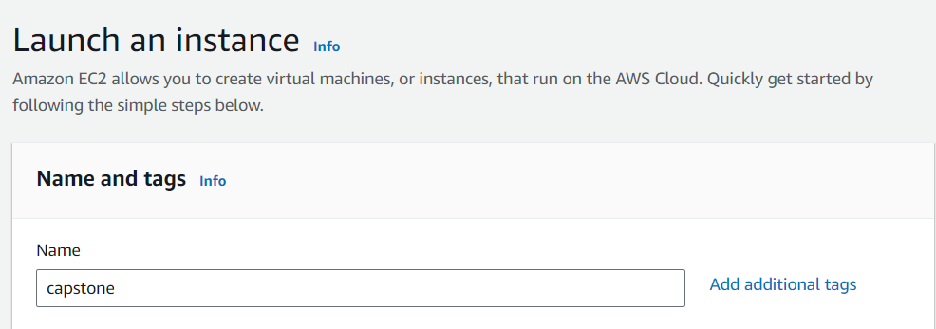

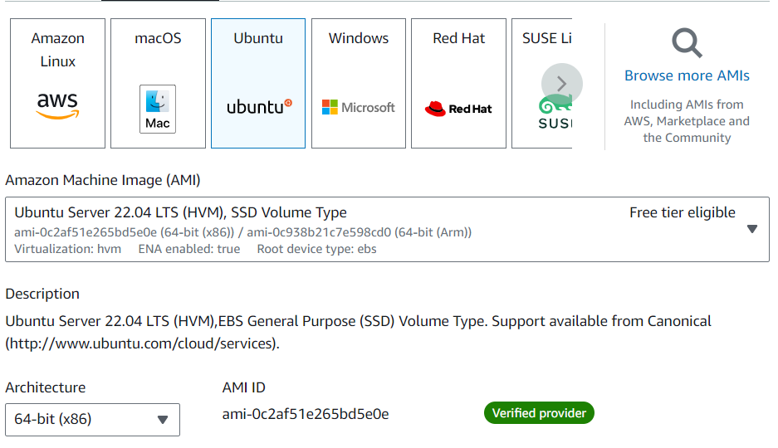





Connect that instance

1. **Git installation:**

sudo apt update

sudo apt install git -y

git --version

sudo apt update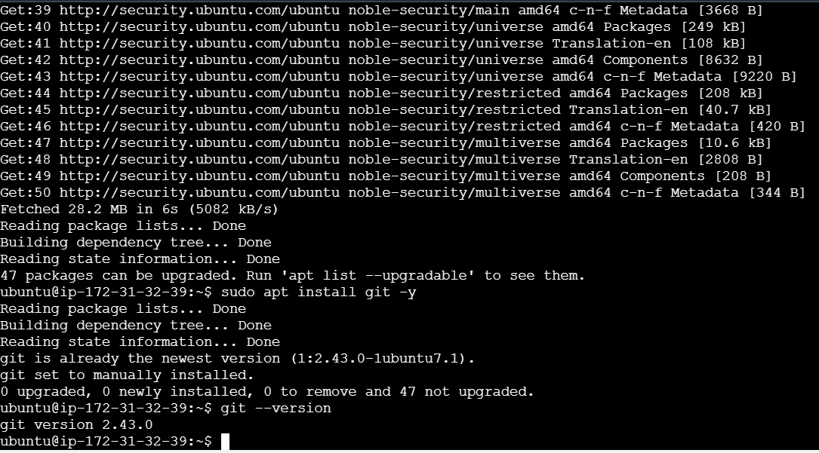



Clone the given repo

git clone <https://github.com/sriram-R-krishnan/devops-build>

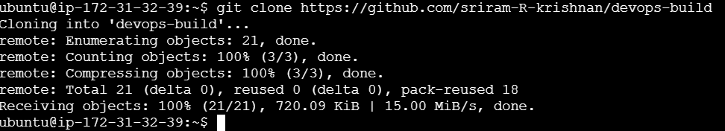

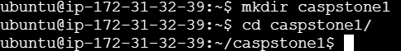

1. **Docker installation:**

sudo apt update

sudo apt install docker.io

sudo docker version

sudo usermod -aG docker ubuntu

sudo systemctl status docker

sudo systemctl start docker

**after that, I got some error regarding permission.so I give below commands. search the below commands in ChatGPT**

sudo usermod -aG docker ubuntu

newgrp docker

sudo systemctl start docker

sudo systemctl enable docker

just check, docker can pull the image from docker hub. This command not needed for this task

sudo docker run hello-world

sudo apt update

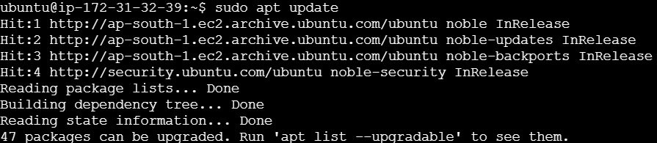

sudo apt install docker.io

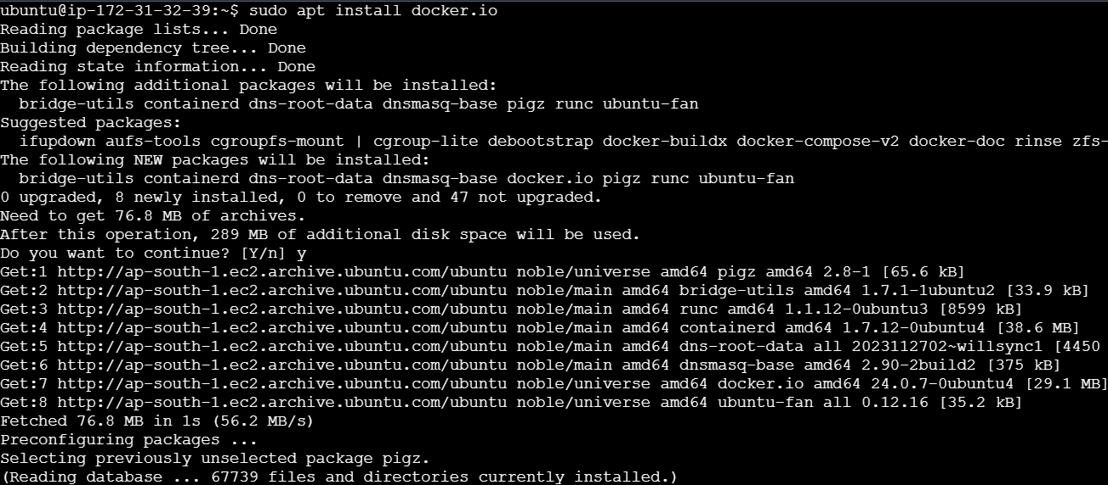

sudo docker version

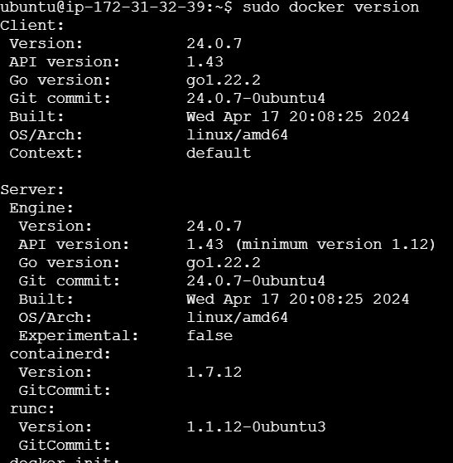

sudo usermod -aG docker ubuntu



sudo systemctl status docker

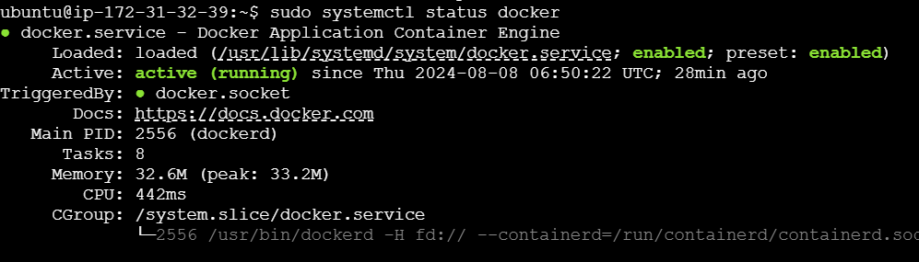

sudo systemctl start docker

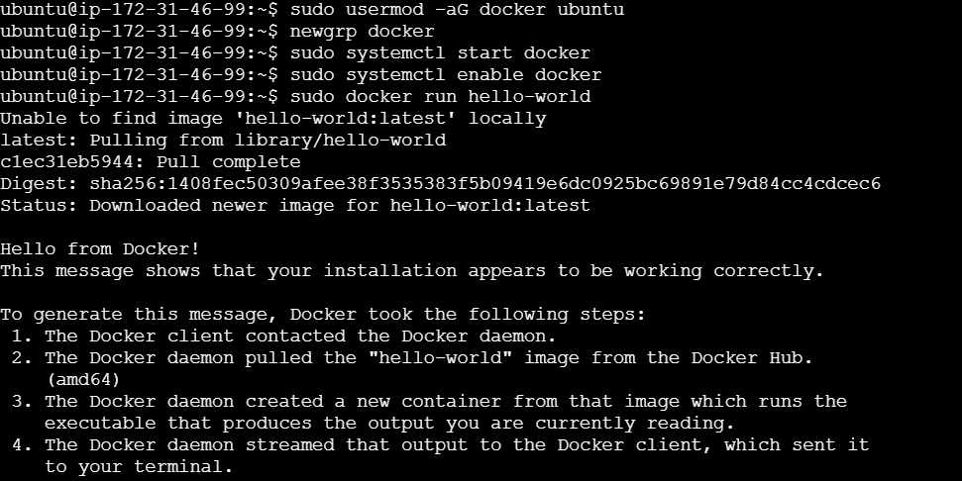

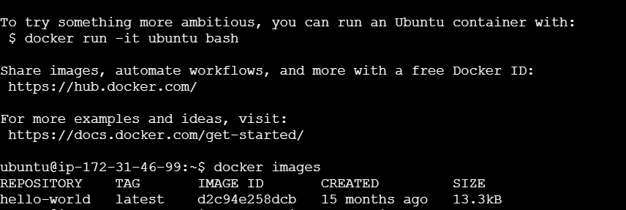

**docker file:**

* In our task given application was already built.
* So, we did not need to write node.js docker file. Just write docker file for nginx server.
* For running the application, we need web server. So, write docker file for nginx web server.
* Because in that server we have to run an already built application.
* **Docker file written in the folder devops-build [in given github this folder available].**
* **so, get into the folder [ cd devops-build]**

**Explanation of the Dockerfile:**

1. **FROM nginx:latest**:
   * This line specifies the base image to use for the Docker image. In this case, it pulls the latest version of the official Nginx image from Docker Hub.
2. **WORKDIR /usr/share/nginx/html**:
   * This sets the working directory inside the container to /usr/share/nginx/html. This is the default directory where Nginx serves static files (like HTML, CSS, and JavaScript).
3. **COPY build/ .**:
   * This copies the contents of the build/ directory [ this dir in the given repo]on your host machine into the current working directory in the container (/usr/share/nginx/html). This typically contains the static files that your web application will serve.
4. **EXPOSE 80**:
   * This line informs Docker that the container will listen on port 80 at runtime. Port 80 is the default HTTP port, so this is where Nginx will serve the web application.
5. **CMD ["nginx", "-g", "daemon off;"]**:
   * This command runs Nginx in the foreground (instead of in the background as a daemon), which is necessary for Docker containers so that the container doesn't exit immediately after starting. The command starts Nginx and keeps it running.

**vi dockerfile**

FROM nginx:latest

WORKDIR /usr/share/nginx/html

COPY build/ .

EXPOSE 80

CMD ["nginx", "-g", "daemon off;"]

**Convert docker file into docker image:**

**docker build -t nginximage . [nginximage -we give that image name for our choice]. This command used for build docker image** 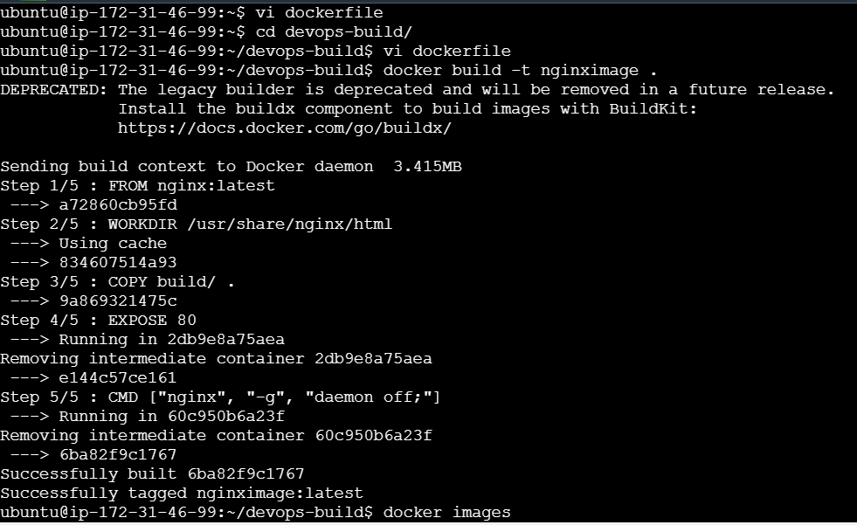



**docker images [check image created or not]**

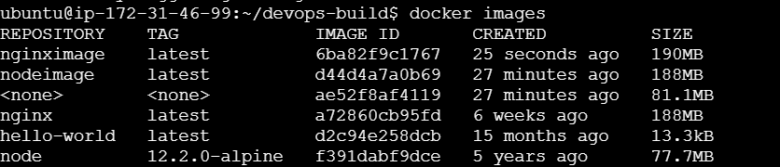

**docker run -d --name mynignxcointainer -p 80:80 nginximage [it is used to create and run a container from a Docker image (nginximage) with specific options]**



**docker ps [ check container created or not]**



**Open the port no :80 in ec2. Copy and paste the ip address**

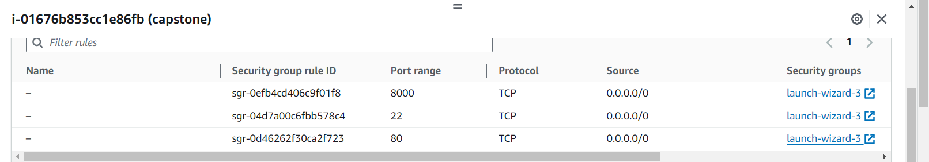

**Output page of given application:**

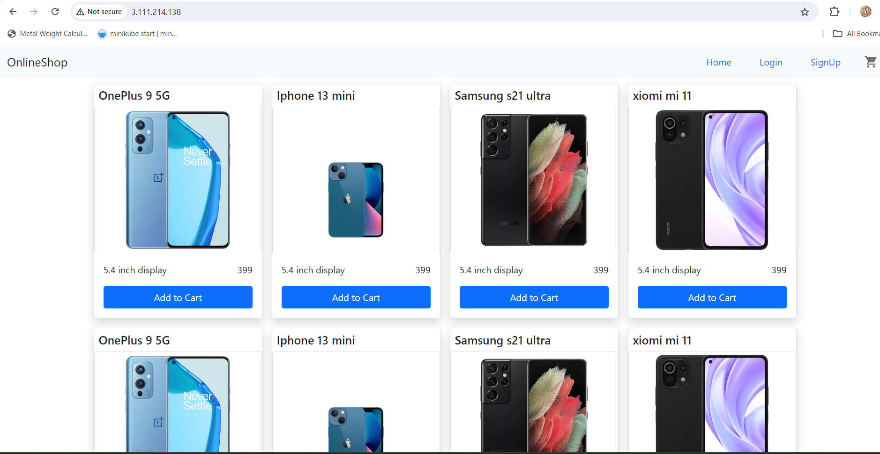

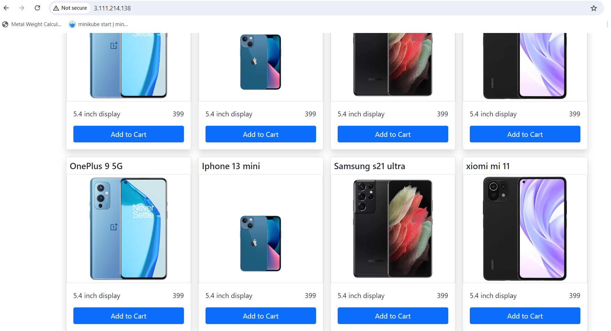

1. **Docker compose installation:**

sudo apt update

sudo curl -L "https://github.com/docker/compose/releases/download/1.29.2/docker-compose-$(uname -s)-$(uname -m)" -o /usr/local/bin/docker-compose

sudo chmod +x /usr/local/bin/docker-compose

docker-compose --version

sudo apt update [ update ubuntu machine]

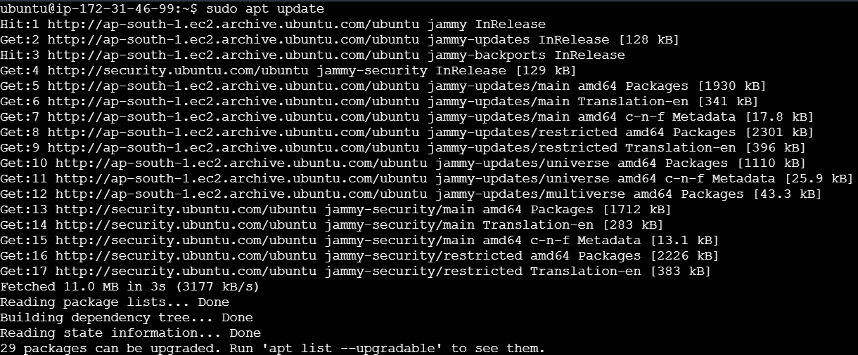

sudo curl -L "https://github.com/docker/compose/releases/download/1.29.2/docker-compose-$(uname -s)-$(uname -m)" -o /usr/local/bin/docker-compose [ install d.c]



sudo chmod +x /usr/local/bin/docker-compose [ gave permission for the d.c]



docker-compose --version [to check docker installed or not / docker version]

**Docker compose file for node js:**

**get into folder devops-build. Then write this**



**vi docker-compose.yaml**

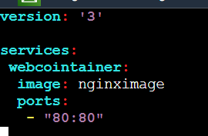

version: '3'

services:

webcointainer:

image: nginximage [ already we created docker image. give that image name]

ports:

* “80:80”

**Give permission for this file:**

**Chmod 777 docker-compose.yaml [ give permission for the docker-compose.yaml file]**



**Execute the docker-compose.yaml :**

**docker-compose up -d [ execute the docker compose file]**



**docker ps [ to check container created or not]**



**Bash scripting:**

* **build.sh**
* **deploy.sh**

**build.sh:**

* The build.sh file is a shell script commonly used in software projects to automate the build process.
* It typically contains a series of commands that compile the source code.
* This script is often used in environments where consistent and repeatable builds are essential, such as in continuous integration (CI) pipelines.

**Build.sh file:**



#!/bin/bash

docker stop mynignxcointainer

docker rm mynignxcointainer

docker build -t nginximage .

docker run -d --name mynignxcointainer -p 80:80 nginximage

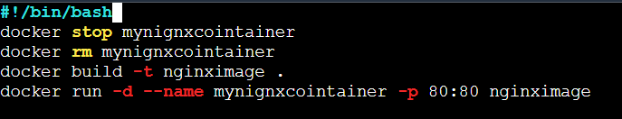

Your docker login details [ create the new docker hub account]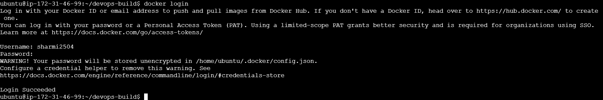

**chmod 777 build.sh** [Give permission for build.sh file] **./ build.sh**[ execute the file]

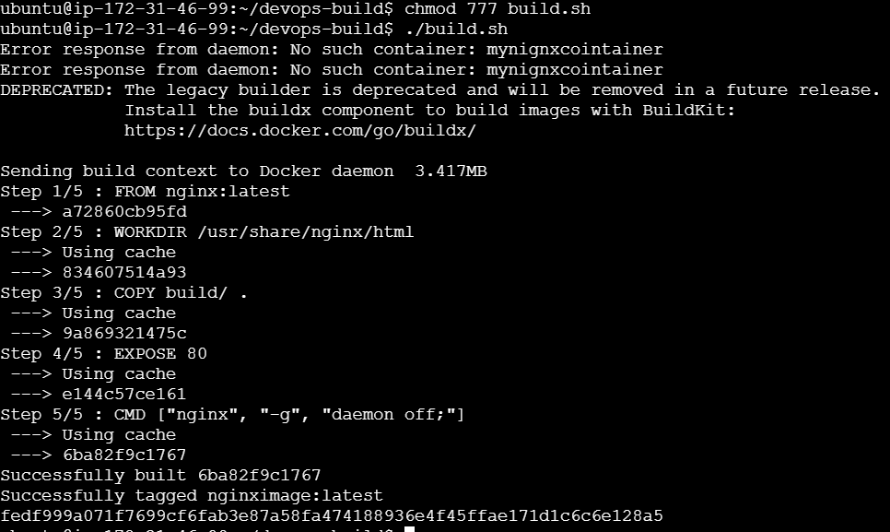

**docker images** 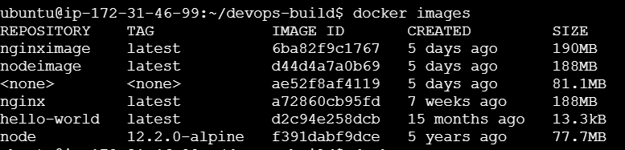

**docker ps**



**deploy.sh:**

* The deploy.sh file is not a standard or widely recognized filename in most deployment processes or tools.
* It could be a custom script or configuration file specific to a particular system, project, or deployment process

**deploy.sh file:**



#!/bin/bash

docker tag nginximage sharmi2504/dev

docker push sharmi2504/dev

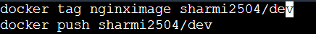

**chmod 777 deploy.sh**

**./deploy.sh**

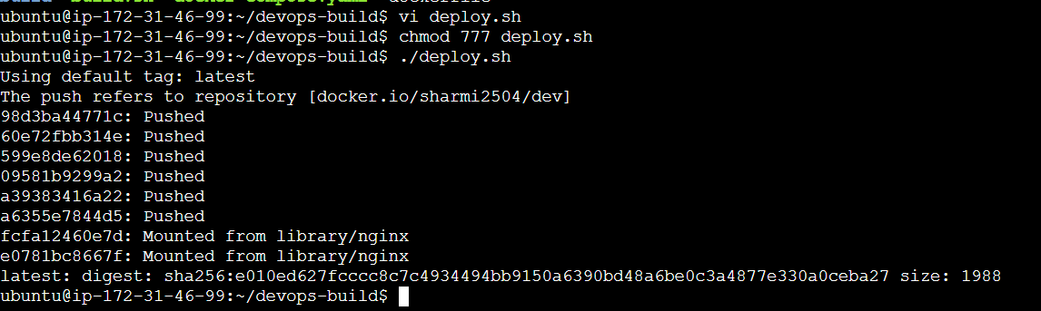

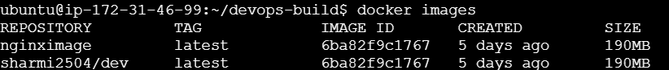

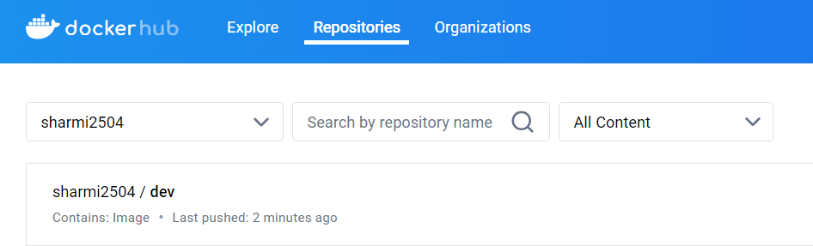

**Create new repo in git:**

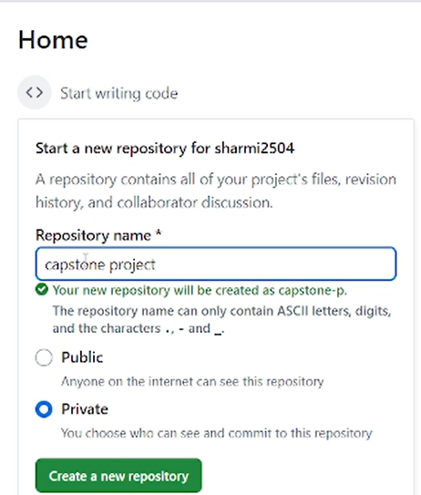



**Give public repo**



After create repo. you get this https link. copy and paste it in clone command



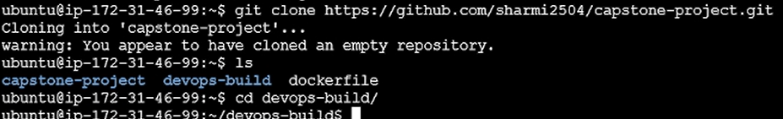

Here capstone-project directory created repo in GitHub. get into that dir . them move that all files from devops-build to capstone-project dir . in our own repo we push all our files.

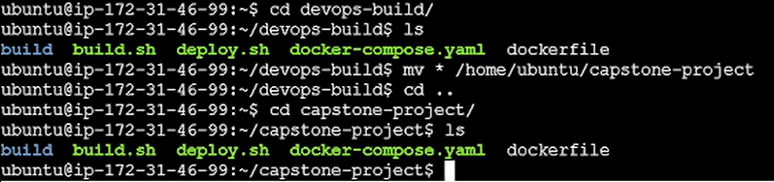

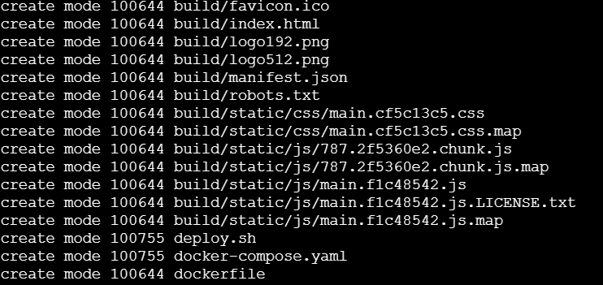

**git add .** [ add all files in our repo]

**git commit -m “add all files”**

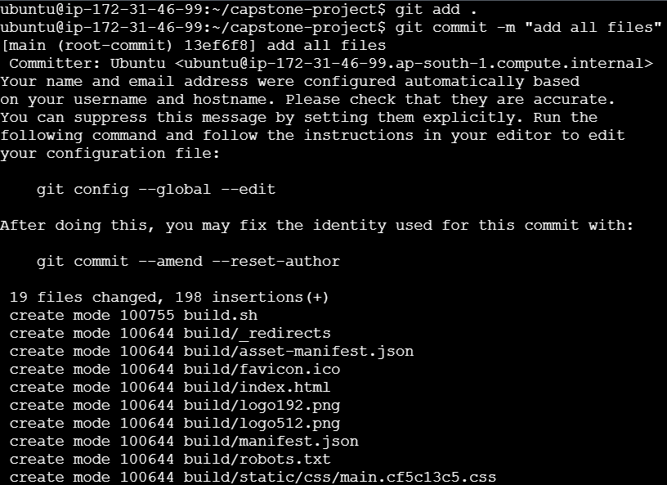

All files move in that repo [ capstone-project]. then created dev branch. Inside dev branch we add all files.

**Create dev branch in git:**

**git checkout -b dev [** Create dev branch**]**





**git add .** [ add all files in our repo]

**git commit -m “add all files”**

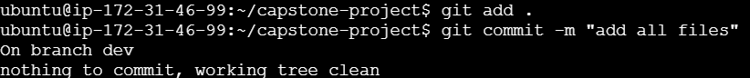

**git push -u origin dev [ push all files in our repo]**

For password we generate token [ that steps given below]

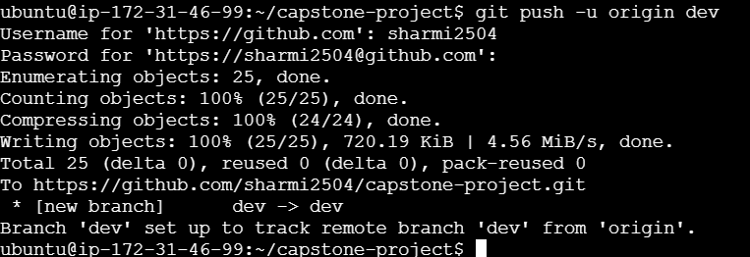

For git password, we generate token





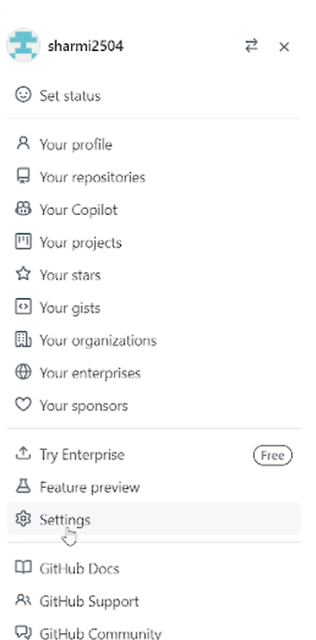

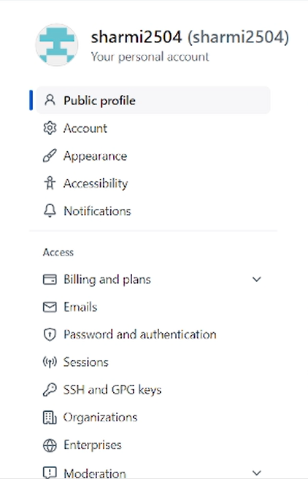

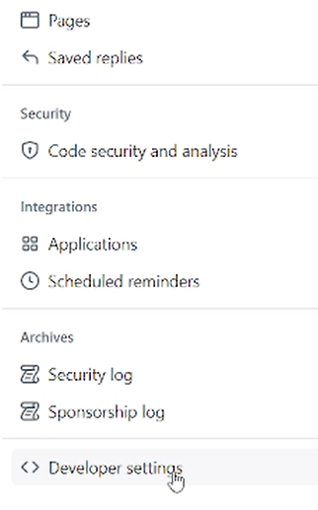



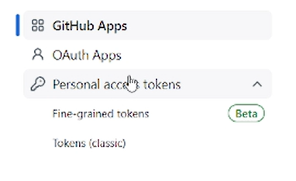





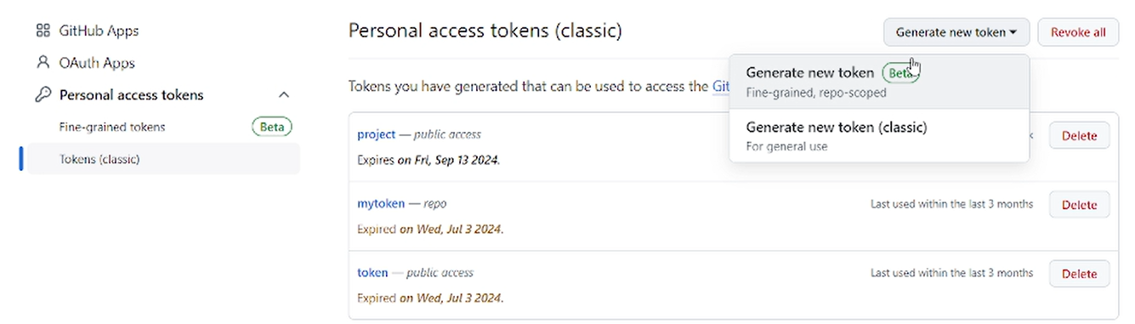

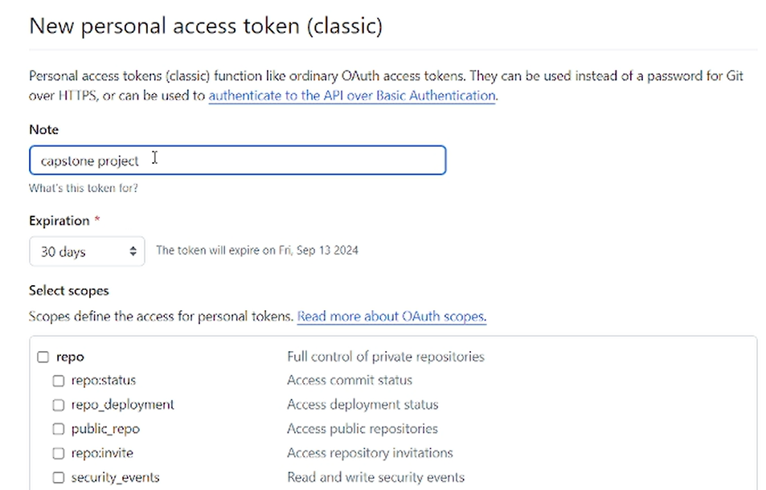

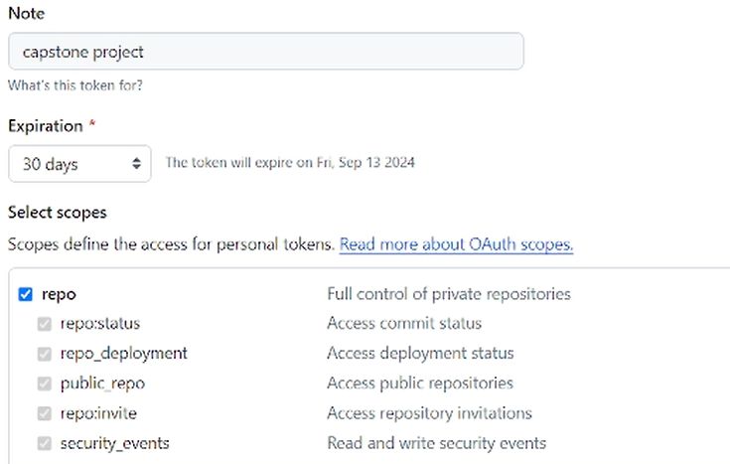

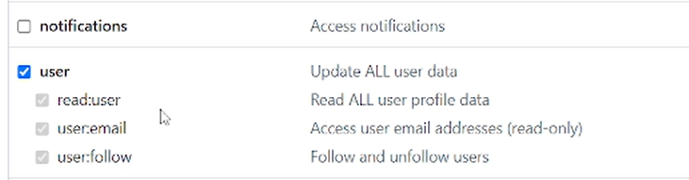

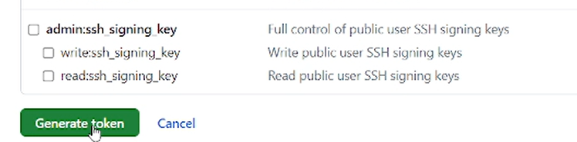

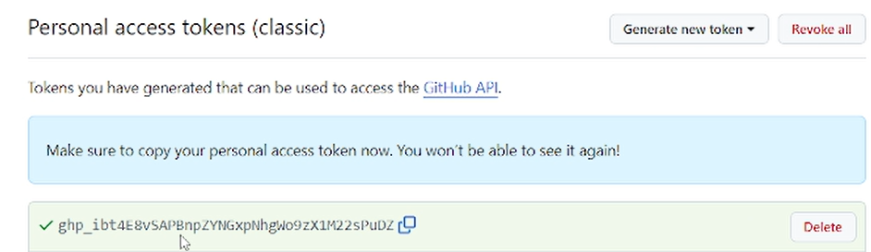

Copy and paste the token in password

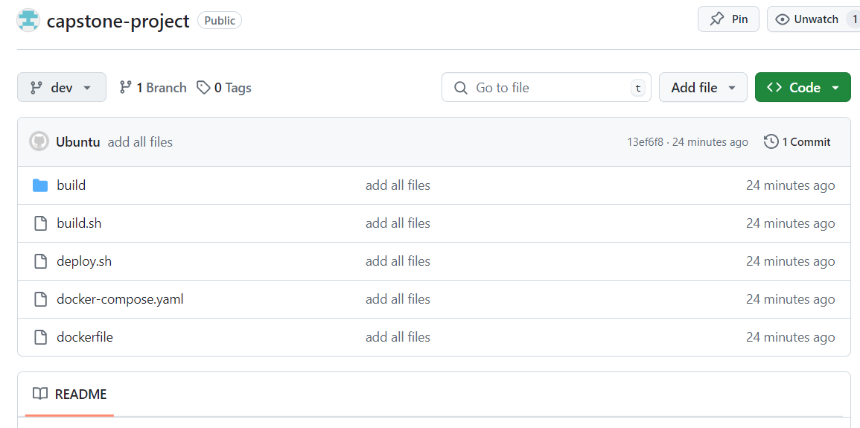

All files pushed to our repo.

1. **Jenkins installation:**

sudo apt-get update

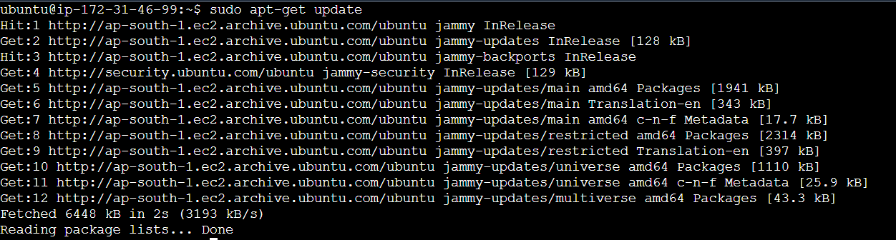

sudo apt-get install -y openjdk-11-jdk [ install docker ,must install java. This is java installation]

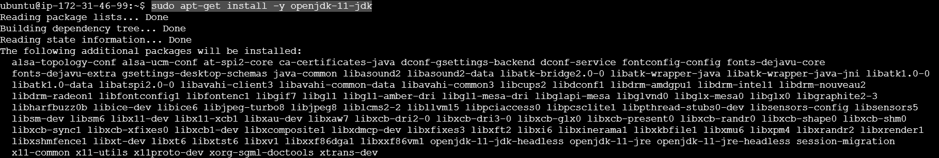

sudo wget -O /usr/share/keyrings/jenkins-keyring.asc \

https://pkg.jenkins.io/debian-stable/jenkins.io-2023.key

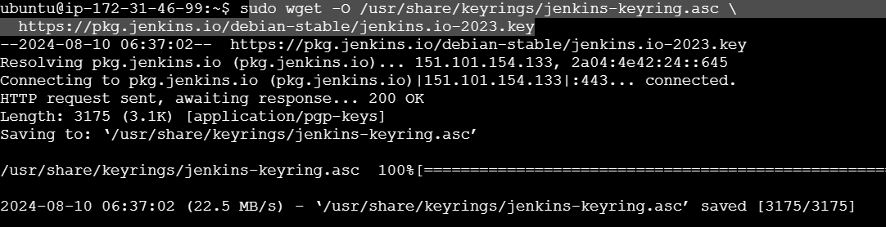

echo "deb [signed-by=/usr/share/keyrings/jenkins-keyring.asc]" \

https://pkg.jenkins.io/debian-stable binary/ | sudo tee \

/etc/apt/sources.list.d/jenkins.list > /dev/null



sudo apt-get update

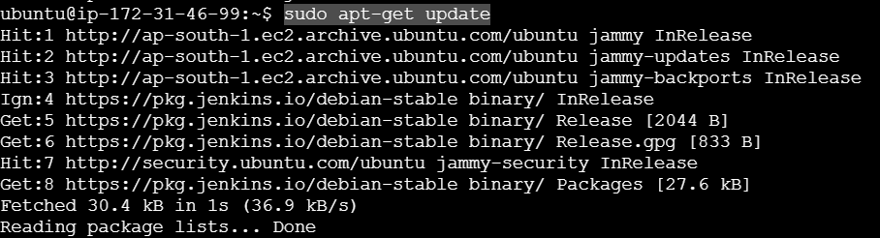

sudo apt-get install Jenkins

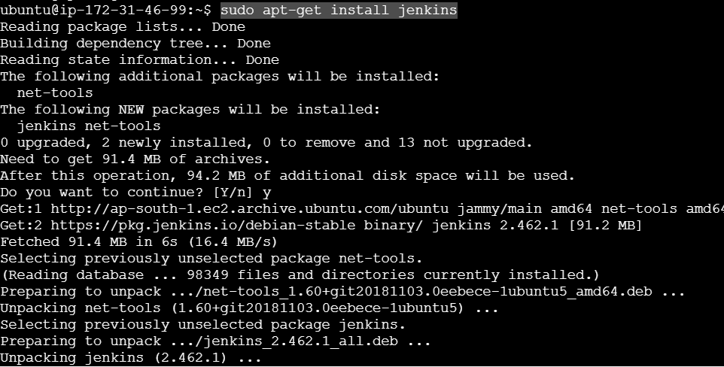

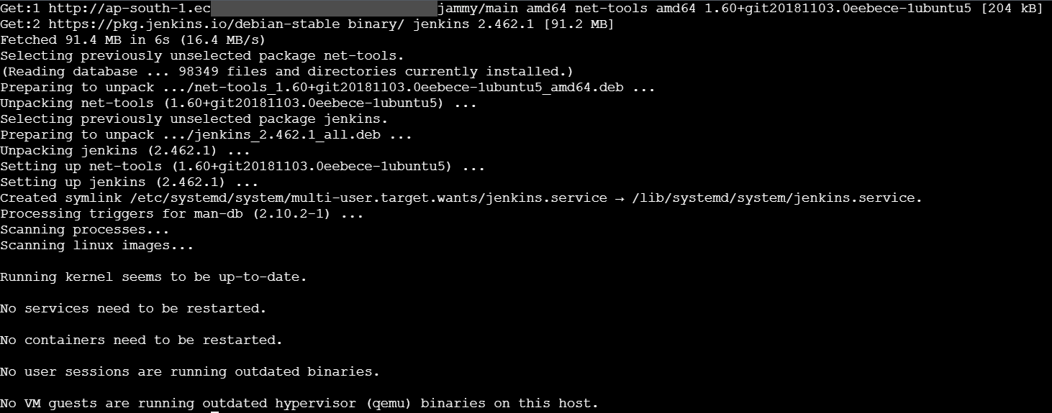

sudo systemctl start Jenkins



sudo systemctl status Jenkins

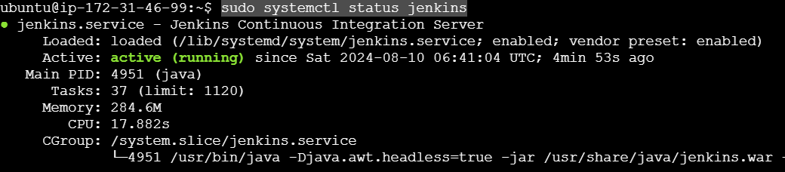

Above command not work. so run the below commands. below commands searched in ChatGPT. If suppose run the below commands ,before that install java.

(OR)

sudo apt-get update [ update machine]



sudo apt-get install -y openjdk-11-jdk [ install docker, must install java. This is java installation]



curl -fsSL https://pkg.jenkins.io/debian-stable/jenkins.io-2023.key | sudo tee \

/usr/share/keyrings/jenkins-keyring.asc > /dev/null

sudo sh -c 'echo deb [signed-by=/usr/share/keyrings/jenkins-keyring.asc] \

https://pkg.jenkins.io/debian-stable binary/ > \

/etc/apt/sources.list.d/jenkins.list'



sudo apt-get update

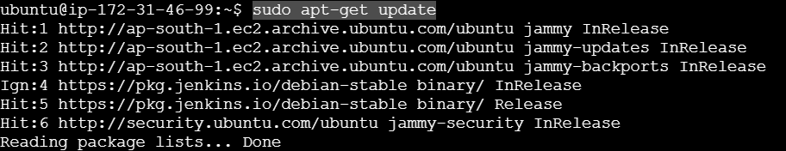

sudo apt-get install Jenkins

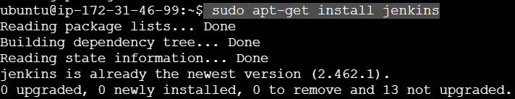

sudo systemctl start Jenkins



sudo systemctl status Jenkins





**Jenkins file:**

pipeline {

agent any

environment {

docker_username = credentials('docker-username-id') // Set up your Jenkins credentials

docker_password = credentials('docker-password-id')

}

stages {

stage('Build') {

steps {

// Build Docker image using build script file

sh './build.sh'

}

}

stage('Login') {

steps {

sh 'docker login -u $docker_username -p $docker_password'

}

}

stage('Deploy') {

steps {

script {

if (env.GIT_BRANCH == "origin/dev") {

sh './deploy.sh'

}

}

}

}

}

}

Add the Jenkins file to github . use the below commands.

**git add jenkinsfile**[ add Jenkins files in our repo]

**git commit -m “add jenkinsfiles”**

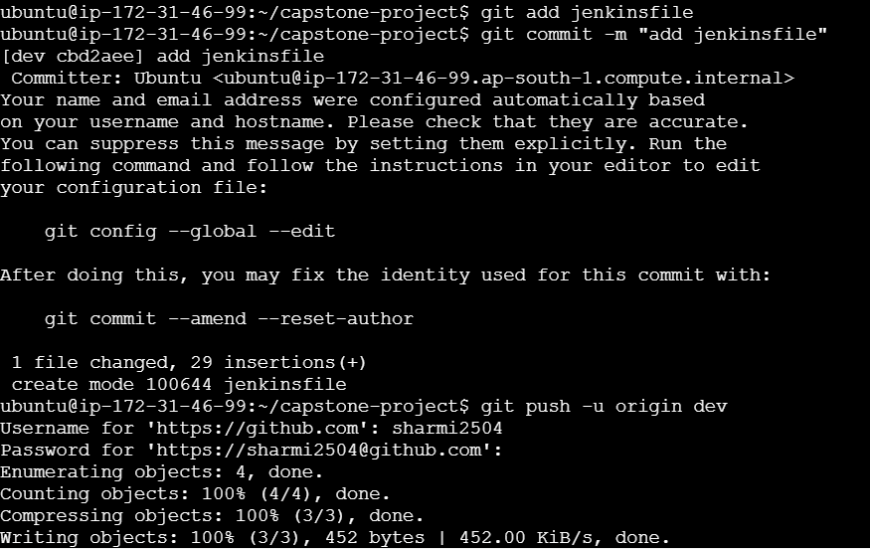

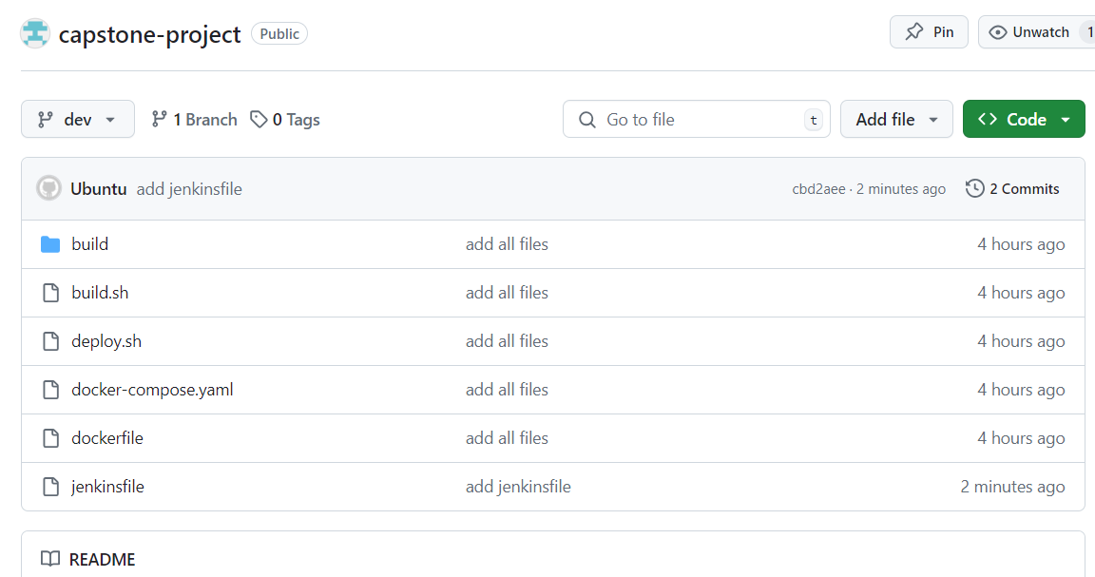

**Setup Jenkins dashboard:**

Add port no:8080 for access the Jenkins browser. Because it is a GUI tool

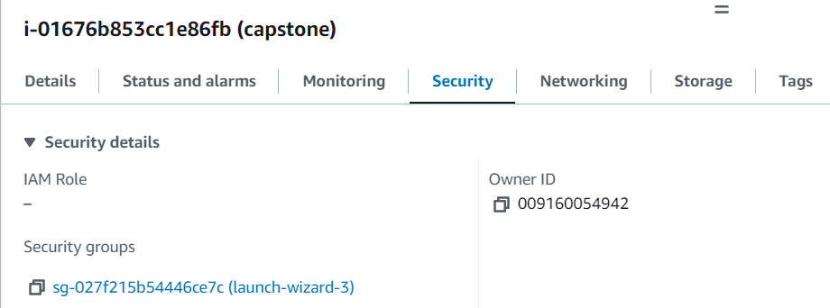

Click edit inbound rule

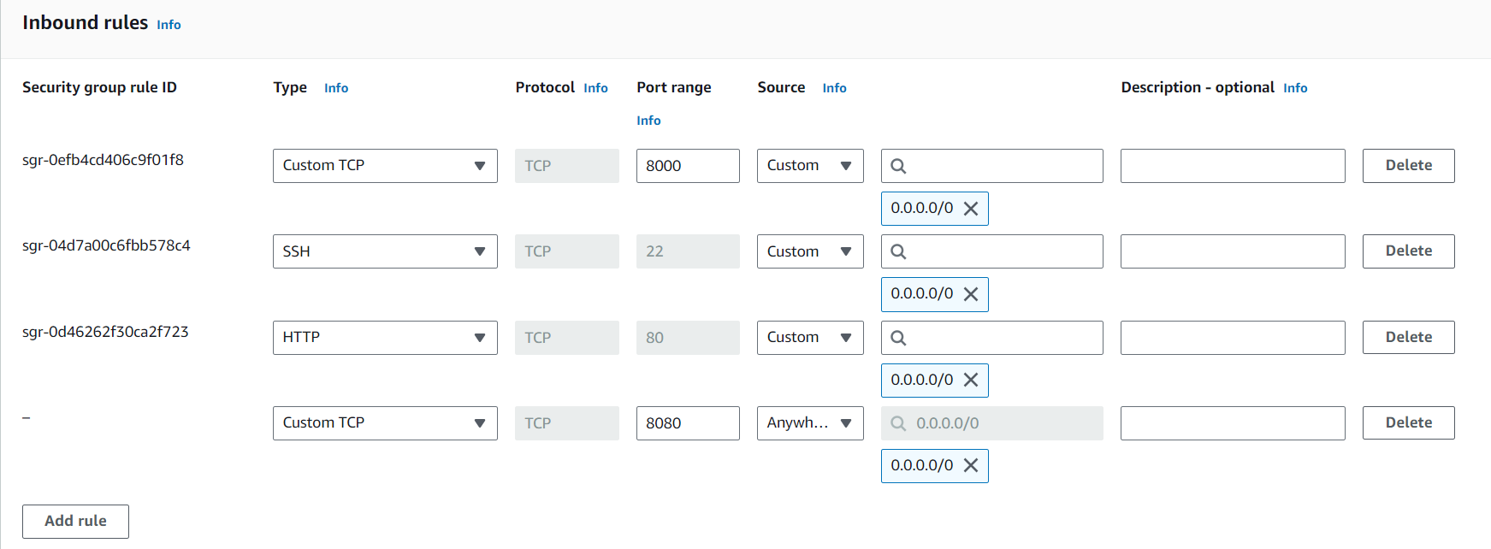

Click add rule 🡪 save rules. Copy ip address. Paste the address [65.2.31.200:8080]. give the Jenkins port number.

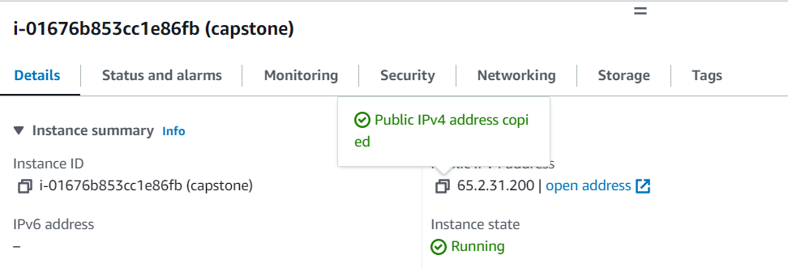

Copy ip address. Paste the address [65.2.31.200:8080]. give the Jenkins port number. Jenkins page opened.

Open Jenkins in browser:

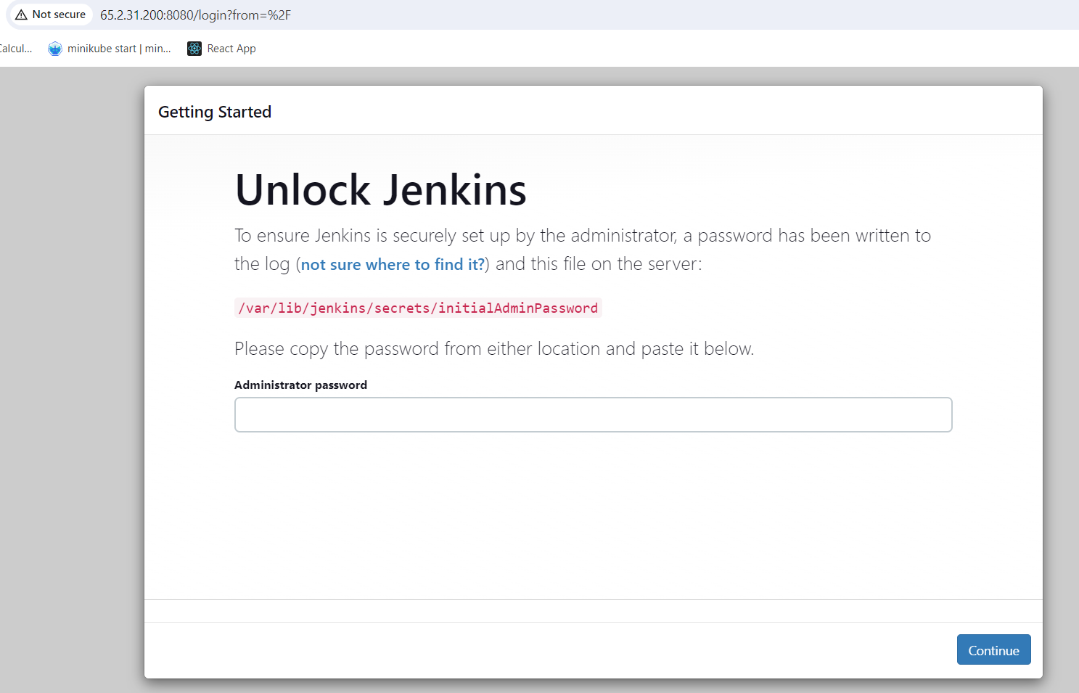

Get above password

sudo cat /var/lib/jenkins/secrets/initialAdminPassword [ get password for Jenkins ]



ef6201f275444ca8a144737522e1fa6d [ copy the password in above]

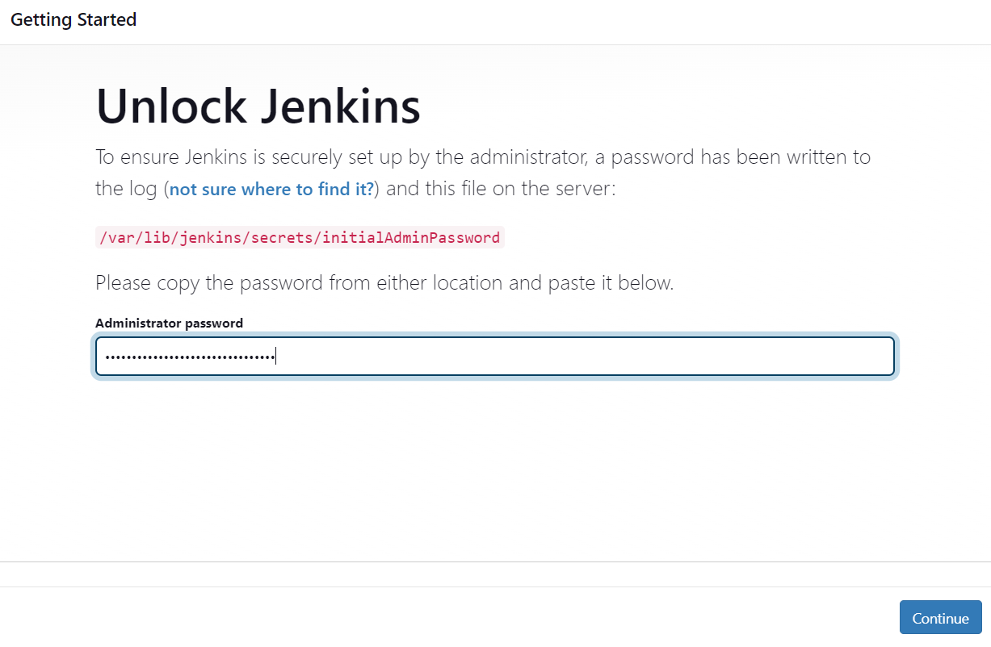

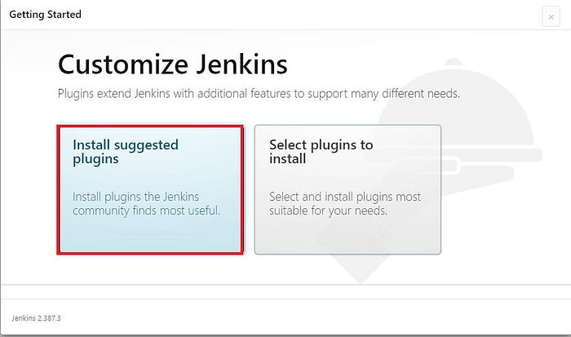

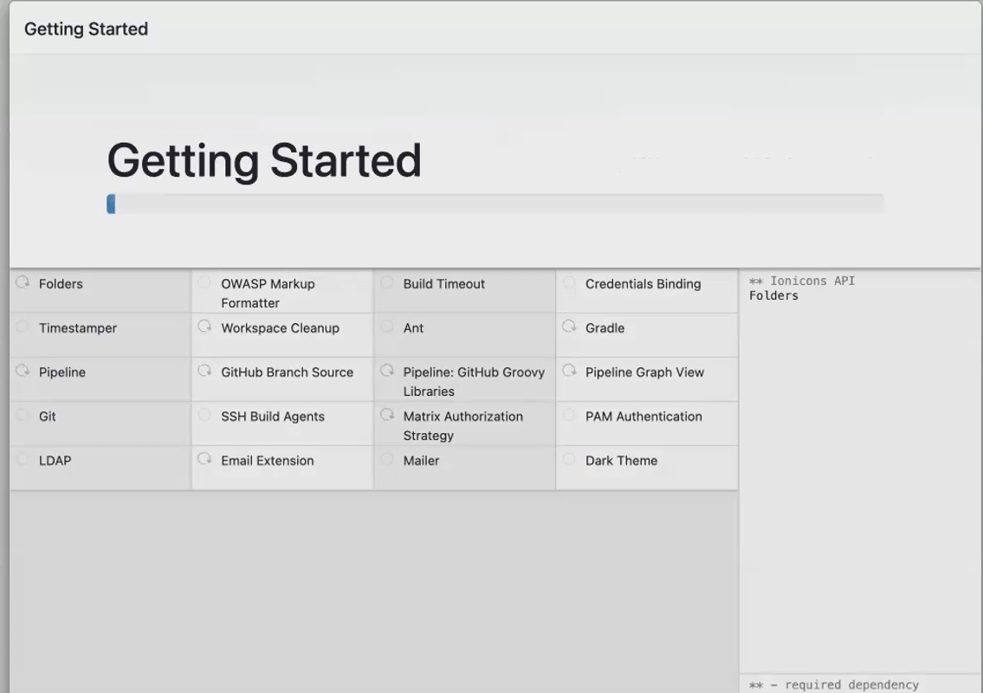

Now let’s create our first Admin user and provide the required info:

Give username as admin, then only we can access all inside Jenkins. In username don’t give your name. In full name you give your name or any other name can be given.

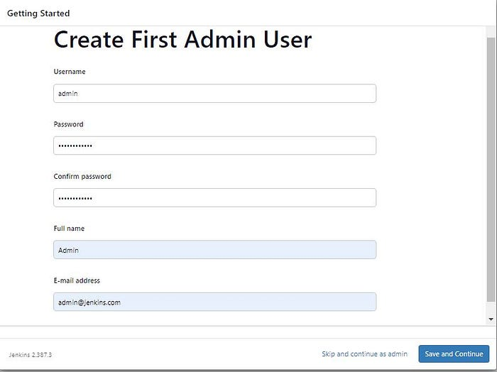

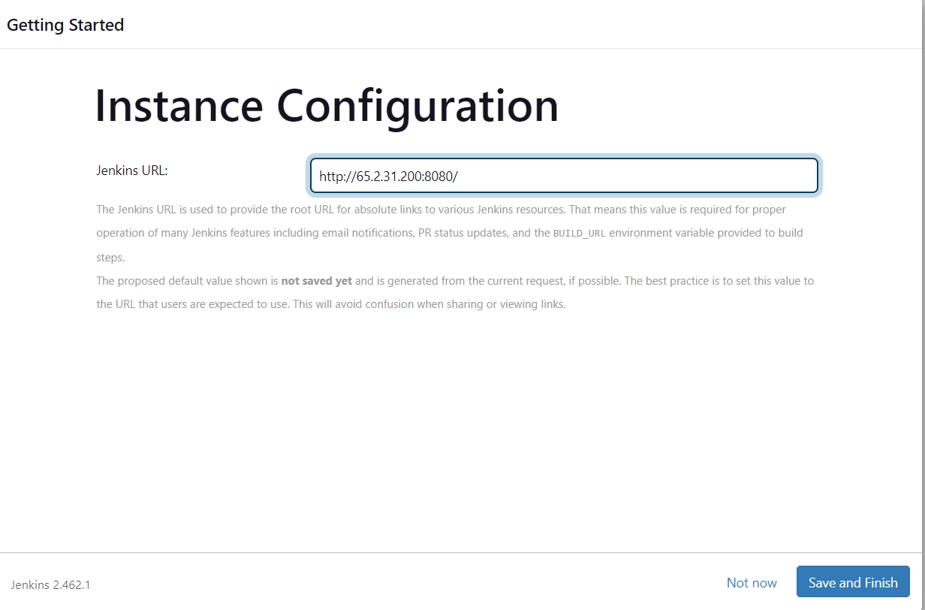

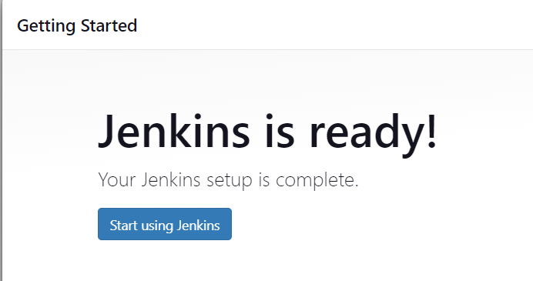

Before creating the job installed docker plugin in Jenkins and install docker in ec2 also.

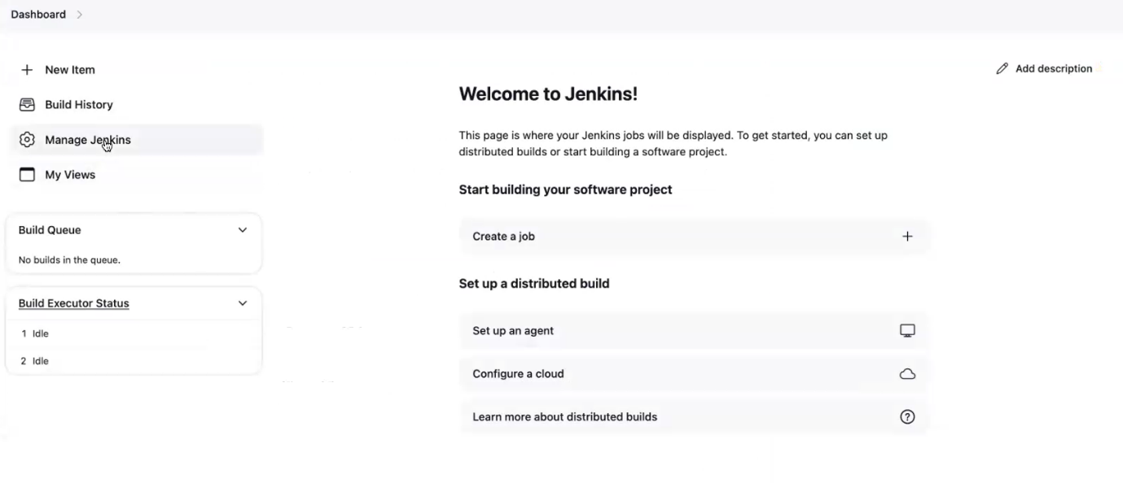



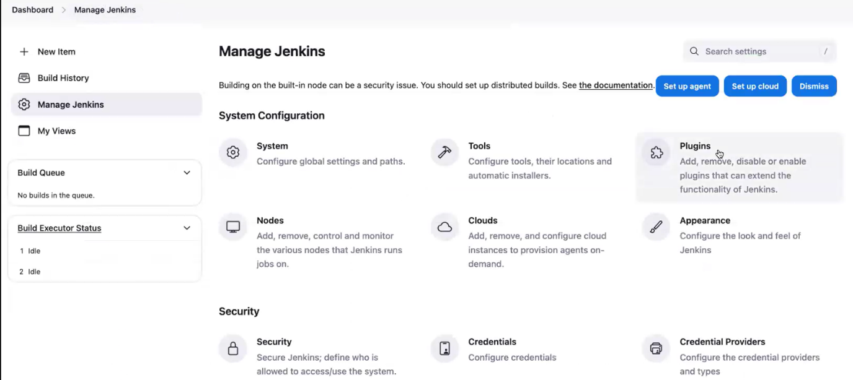

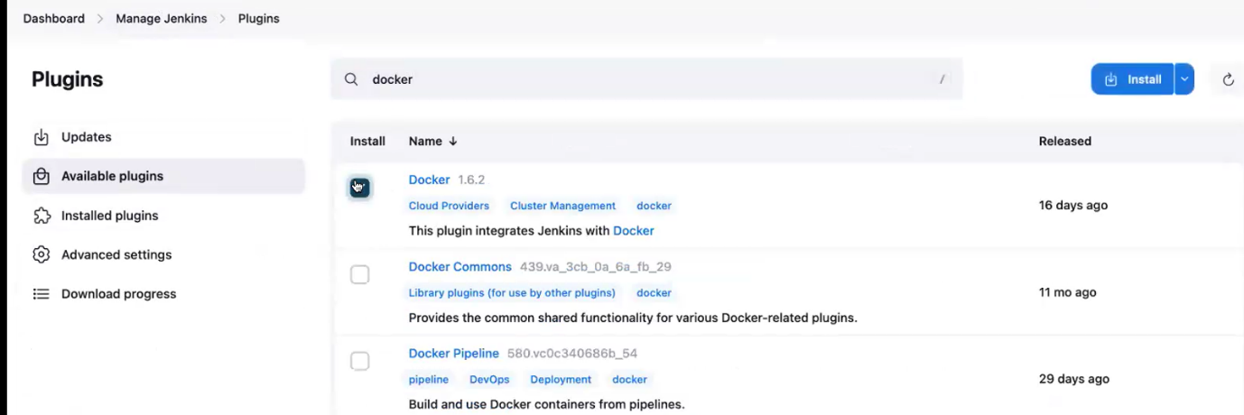

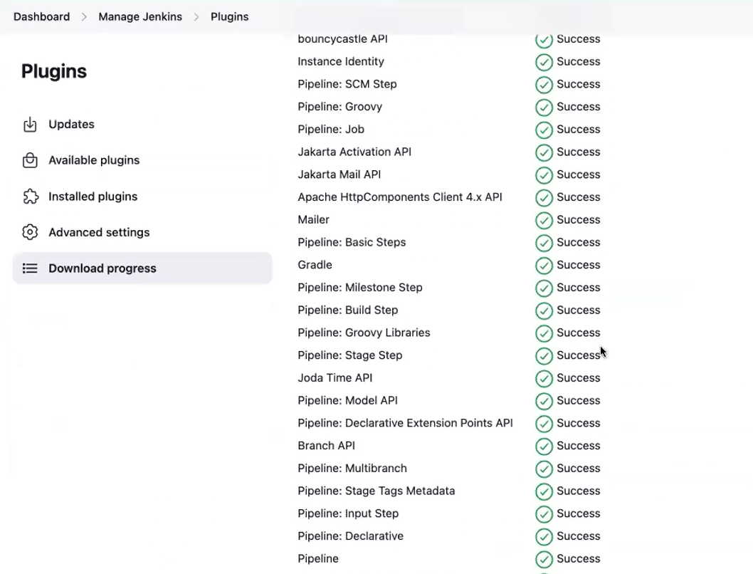

**Suppose docker already in ec2. then check it is installed or not by using command [docker –version]**

**Give docker permission for Jenkins. then only we have to build the docker image.**

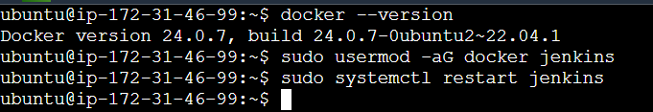

After give restart Jenkins, refresh the Jenkins page. again, ask Jenkins login and password.

**Add credentials:**

we have to pass the credentials for the Doctor Hub. **to push your image to the docker hub registry. You need to do a docker login. So, for docker login. You have to give the username and password. So, your Jenkins have to do the docker login.**

Add credentials

Click dashboard 🡪 manage Jenkins🡪 credentials

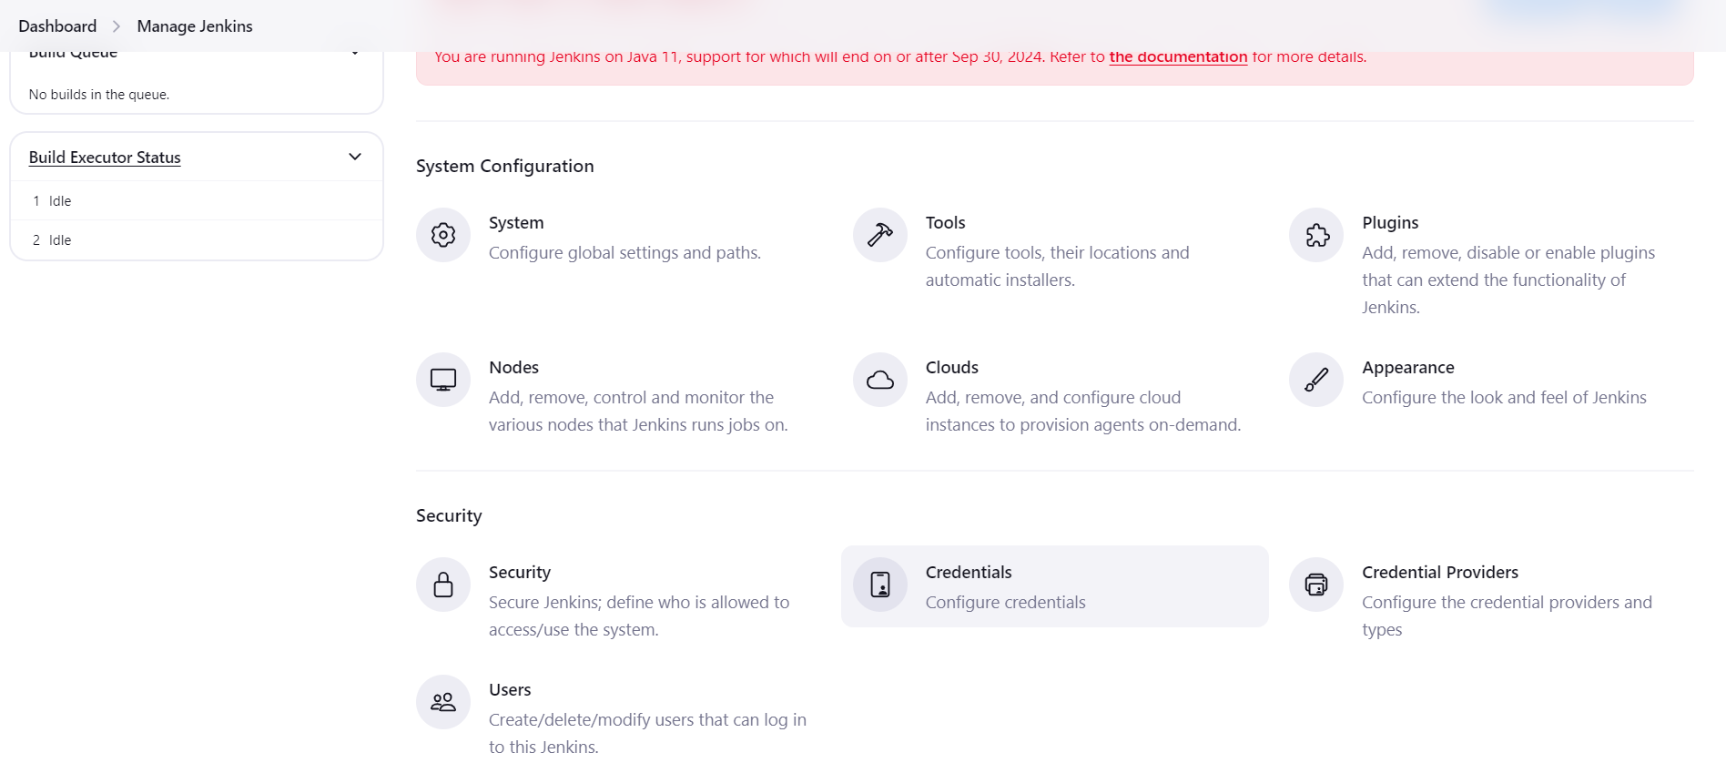

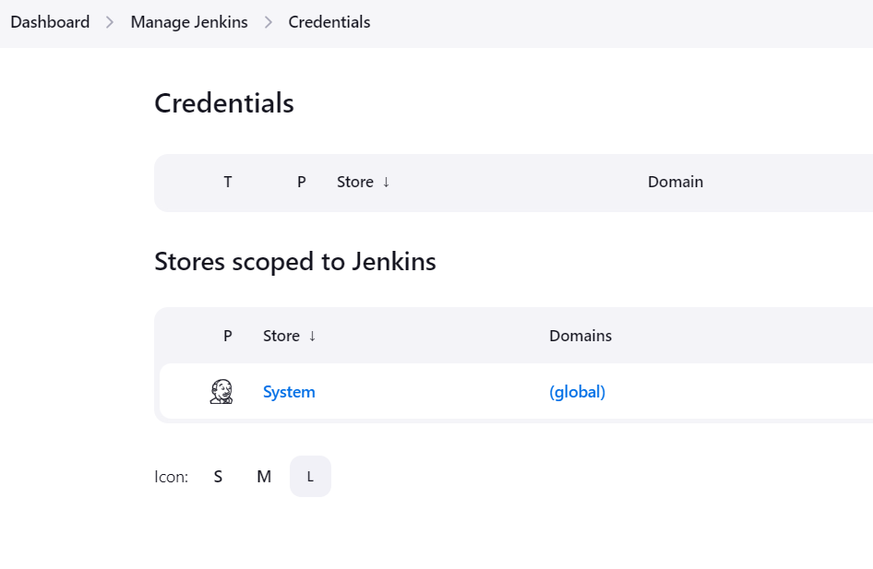

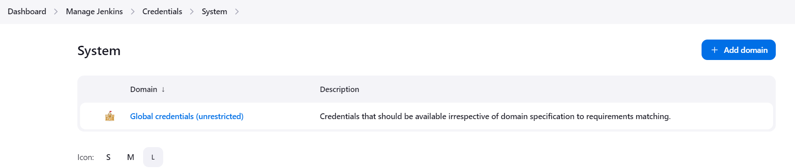

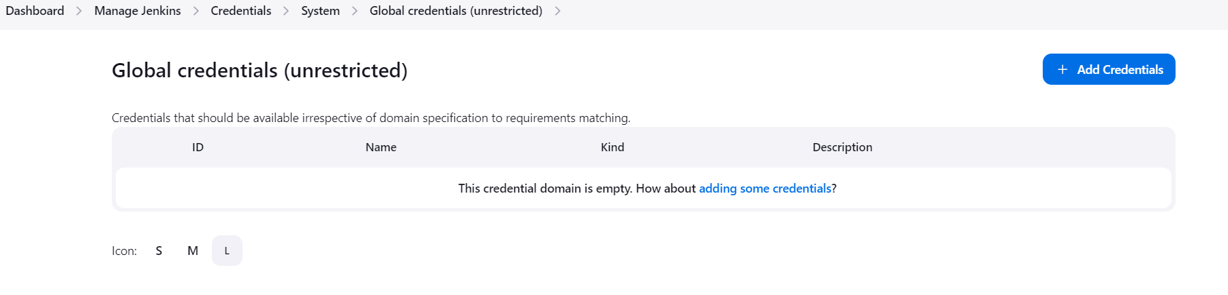

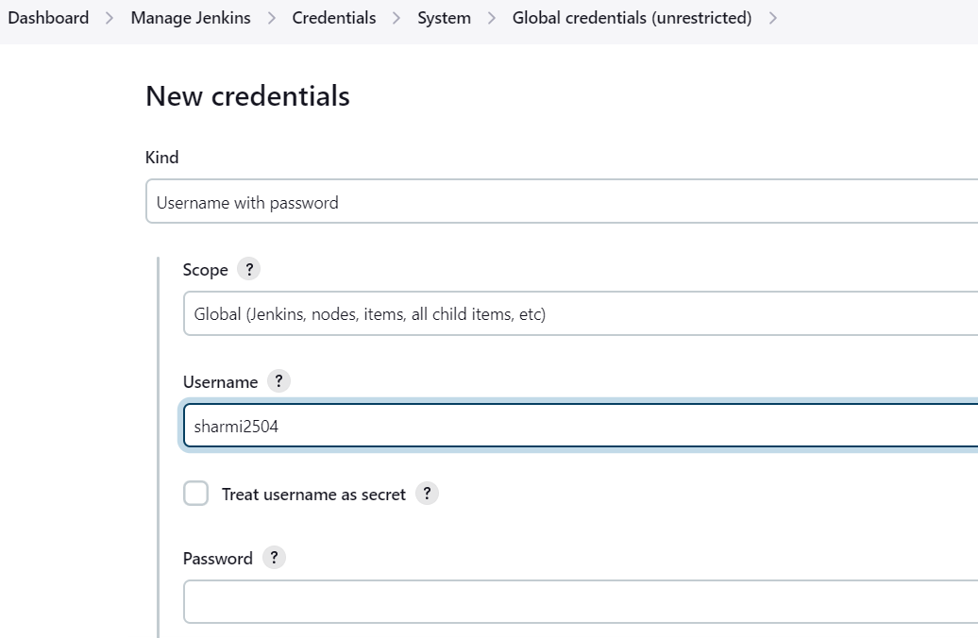

Above username is dockerhub user name.For password we generate tokens like github.

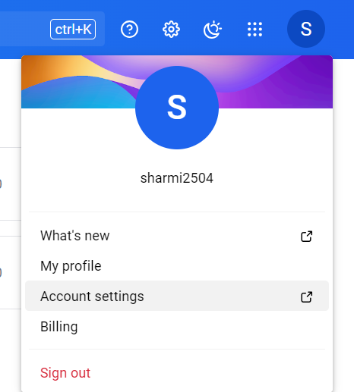

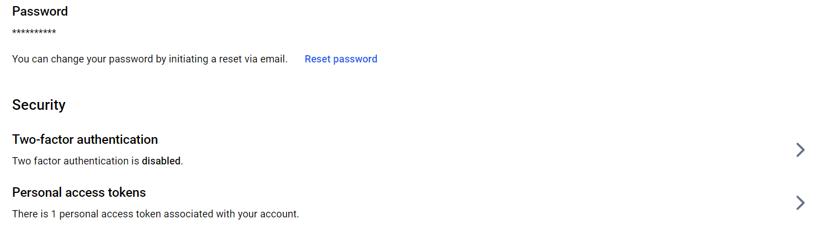

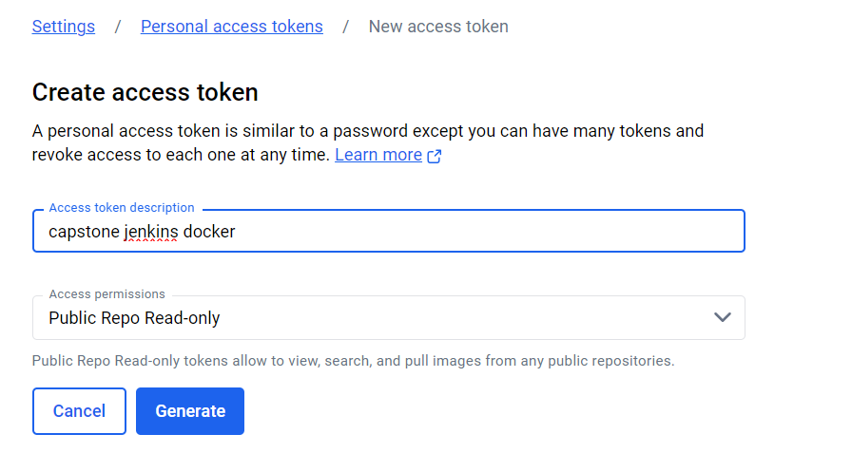

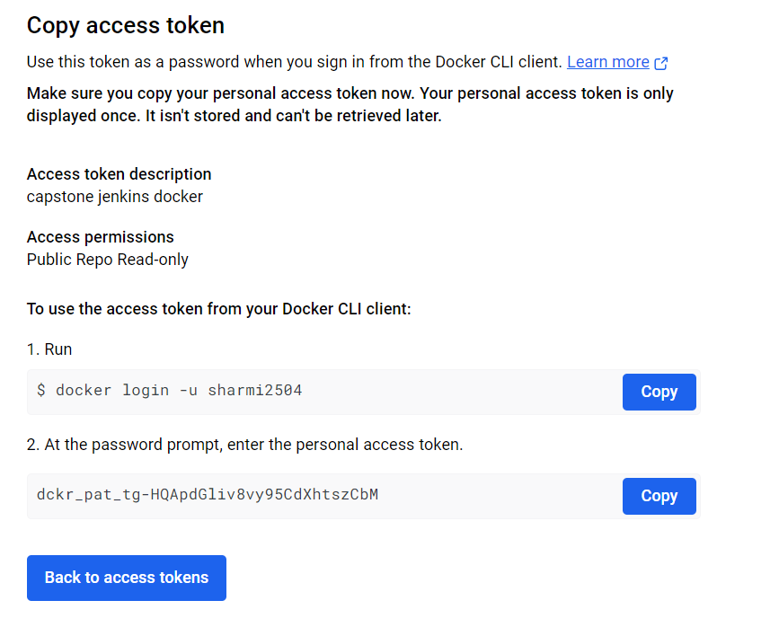

Copy the token, paste it in Jenkins

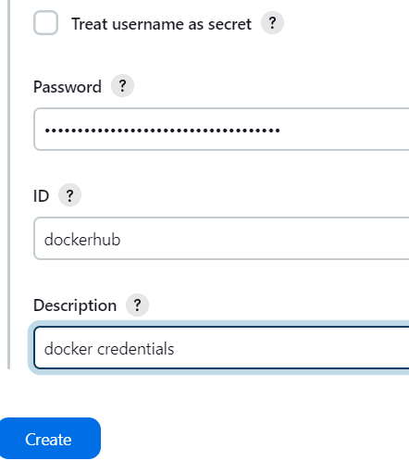

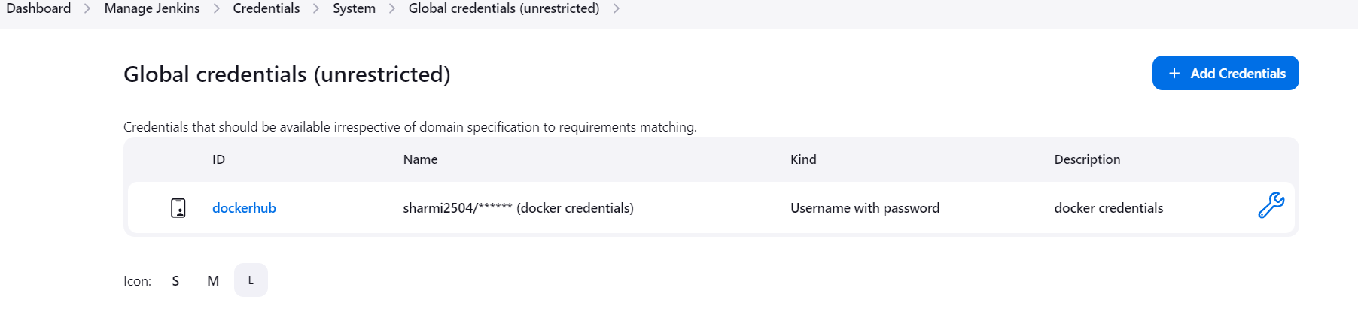**Now create the job in Jenkins:**

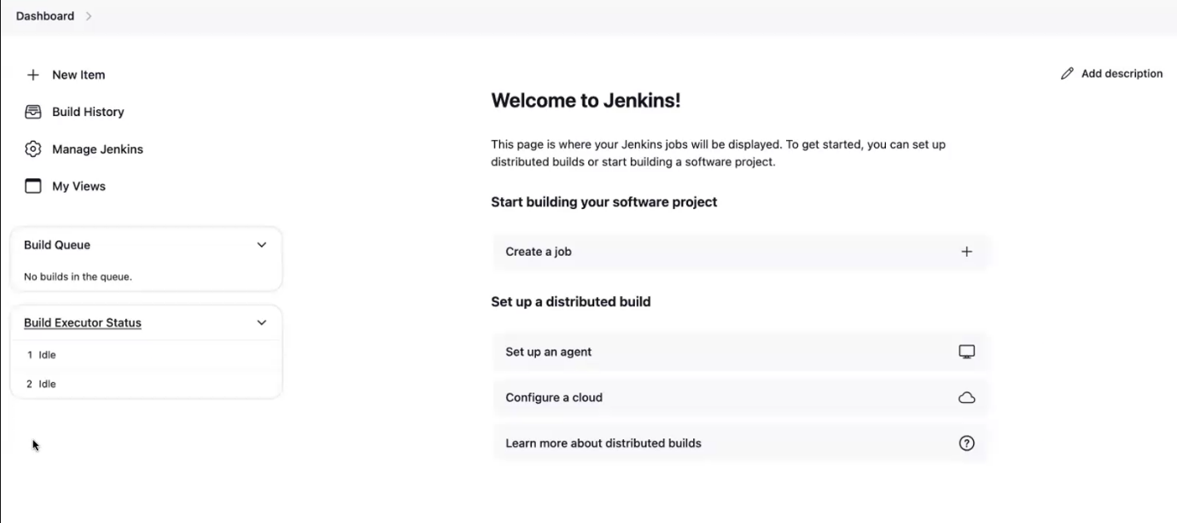

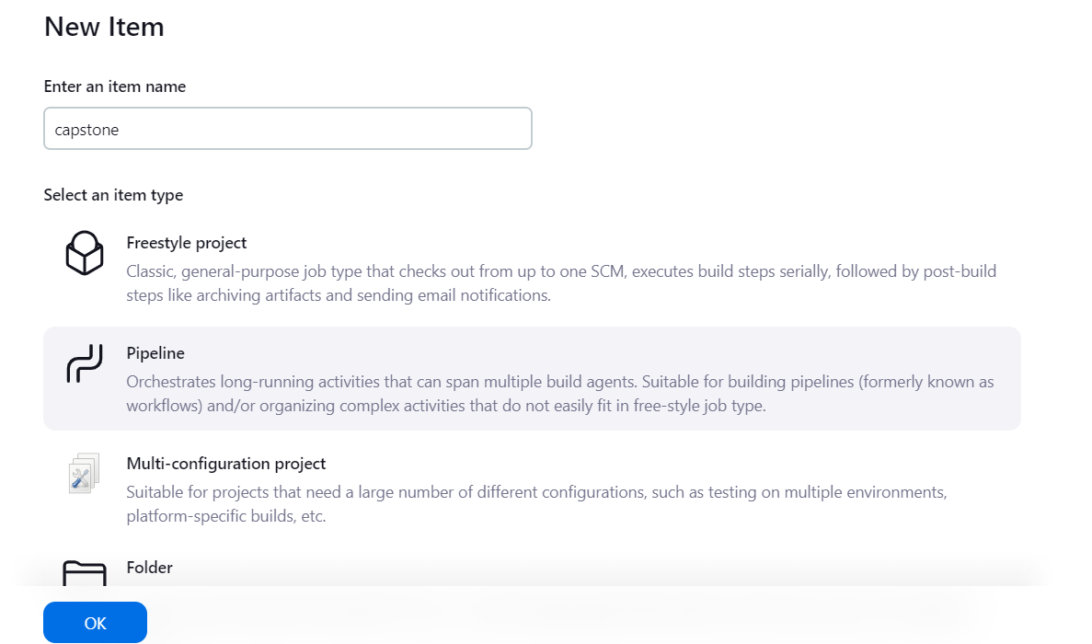

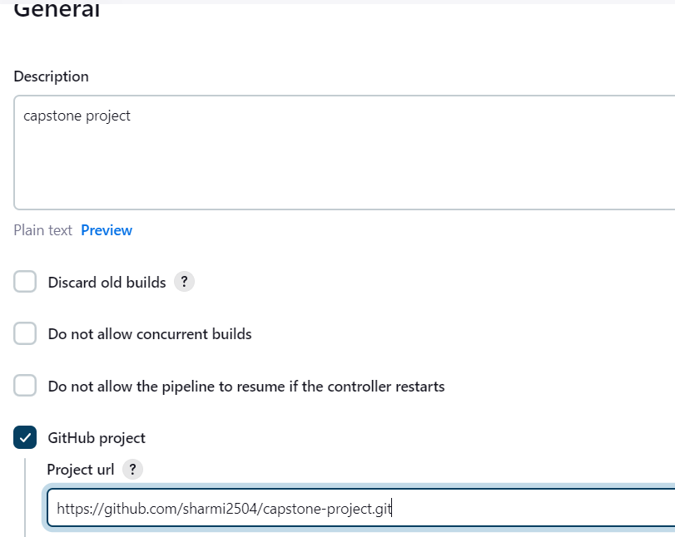

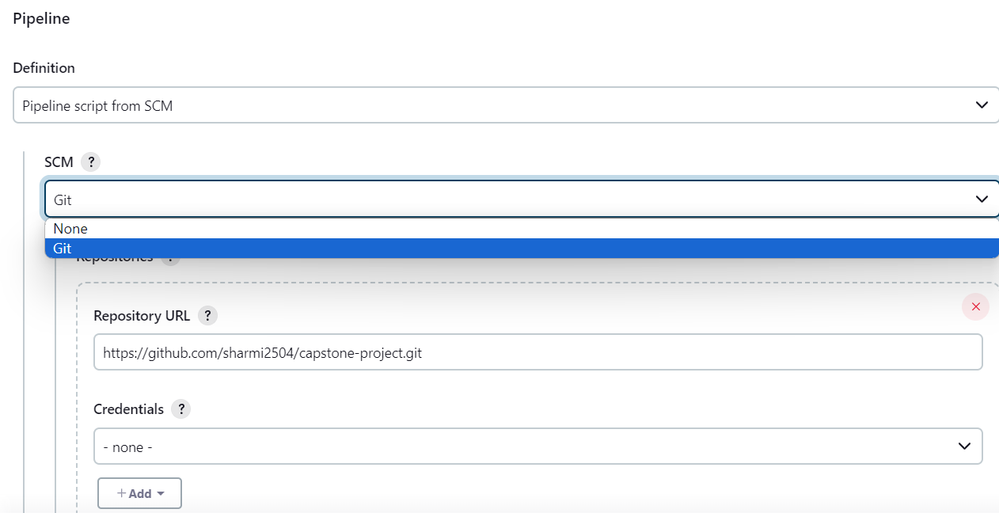

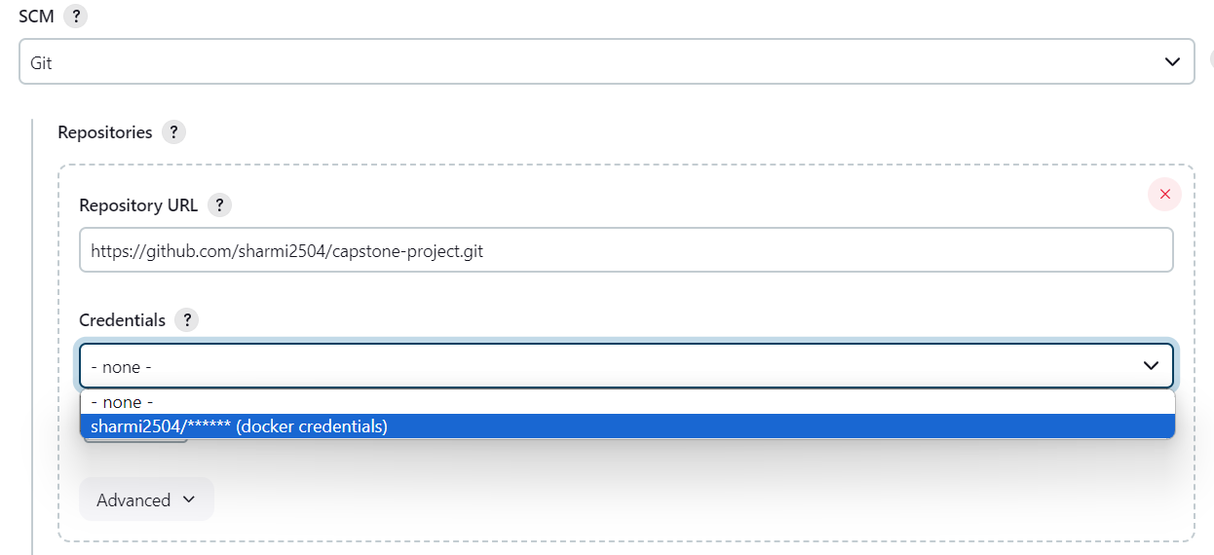

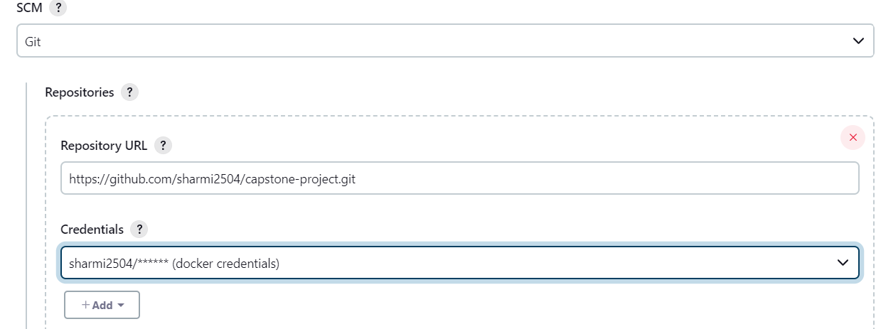

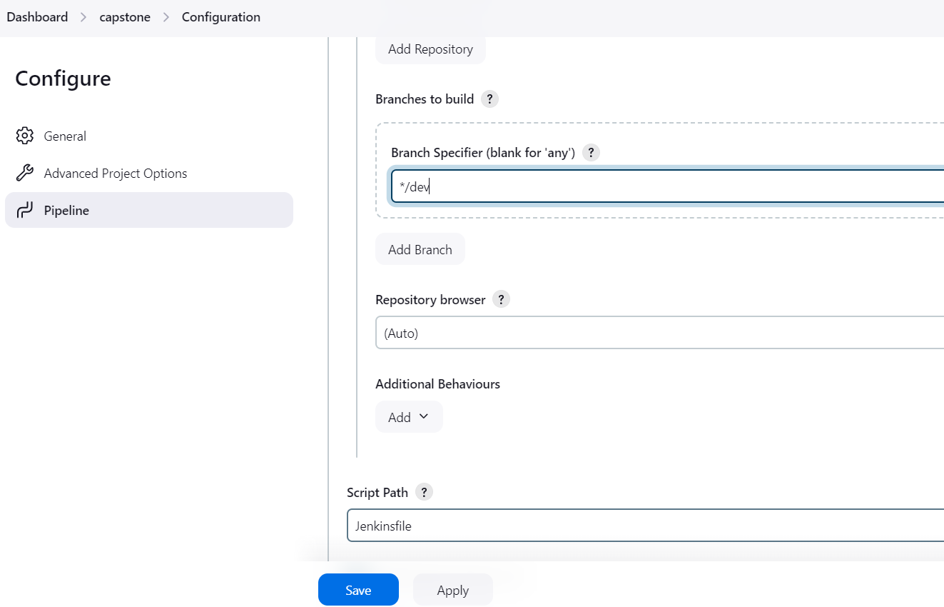

Here I gave j as capital. you give small j . because in git, Jenkins file name as jenkinsfile.

 give correct name. then only fetch the code from github.

Click apply and save

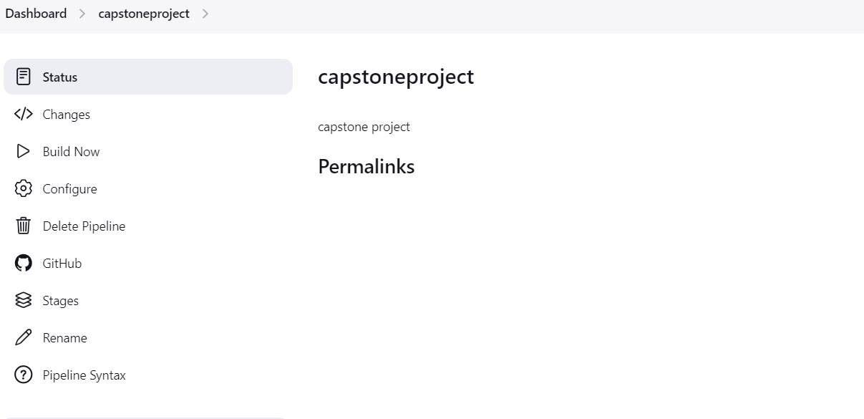

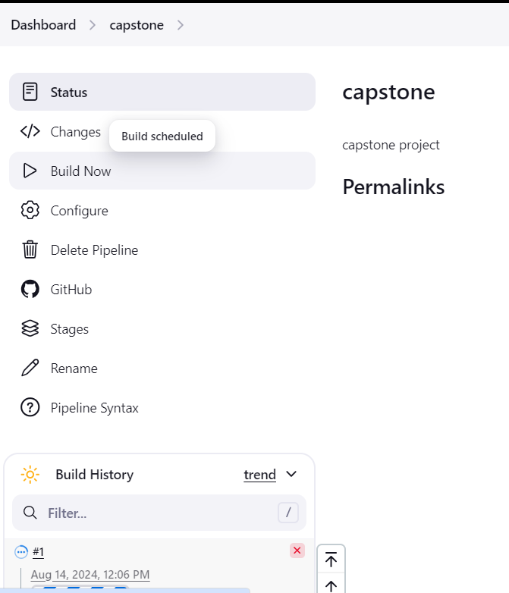

After build I have errors. So I stopped.